Schedule a Library Consultation

Make an Appointment Online

Research Consultations
We can help you with all parts of the research process, from narrowing your topic and starting your research, to evaluating and citing your sources. Not finding what you need: make an appointment!
- Go to the library website lib.montana.edu
- Click Ask the Library.
- Click Schedule an Appointment.
- Choose a date and time, or select a specific Librarian to work with.
- Tell us about your topic or project.

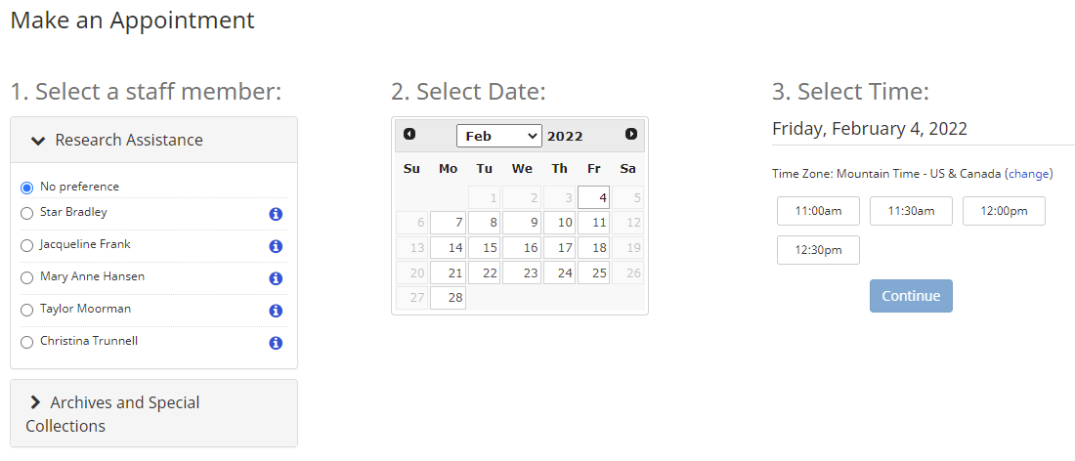

Archives and Special Collections Consultations
We offer research help on using primary sources, archives, and special collections.
- Follow steps 1-3 above
- Click the section for Archives and Special Collections
- Choose a date and time, or select a specific person to work with.

