Library Research

Online Guide: MSU Library Research
- Starting from the library website lib.montana.edu, click Find
- Click Guides
- Search for Library Research
- Or go to the URL guides.lib.montana.edu/LibraryResearch

Quick Search: Articles

Search for Articles in CatSearch
- Starting from the library website lib.montana.edu, enter search terms in the CatSearch box.
- Limit to Articles on the search results page.
- Explore options to limit to 'Peer reviewed', by subject, author, date and others.
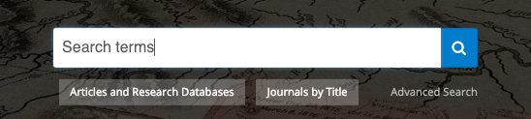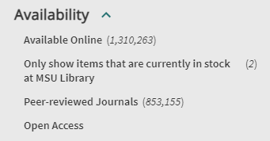

Accessing an Article from CatSearch
- Click on 'Full Text Available' if the library has access.
- Then follow the light blue links to get the full article from one of the listed databases.

Search Articles by Subject Area
- Starting from the library website lib.montana.edu click Find.
- Click Articles & Research Databases.
- Click the All Subjects drop down menu to filter by subject.
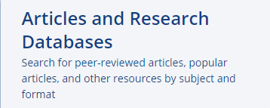
- Choose your subject. A list of suggested databases will appear.
- Select a database to start searching in, then enter keywords – if there are multiple search boxes, enter one keyword per box.

Accessing an Article from library Databases
- Click on ‘Check MSU Availability’
- Click on 'Full Text Available' if the library has access.
- Then follow the light blue links to get the full article from one of the listed databases.

Off Campus Access
- Start your search from the library website
- Sign in with your NetID when asked. You will only have to sign in once.

Search Books

Search for Books in CatSearch
- Starting from the library website lib.montana.edu, enter search terms in the CatSearch box.
- Limit to Books on the search results page.
- Explore options to limit to Books, by subject, author, date and others.
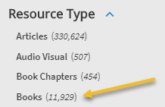

Search by Format: News & Media
- Starting from the library website lib.montana.edu click Find.
- Click Articles & Research Databases.
- Click By Format. Scroll down to the list of formats.
- Choose your format. A list of suggested databases will appear.
- Select a database to start searching in, then enter keywords – if there are multiple search boxes, enter one keyword per box.

Search by Format: Images
Suggested sites to search for images with reusable copyright designation:
- Google Images: images.google.com
  - Search by keyword in Google, click Images under search bar, click Tools, click Usage Rights, click Labeled for Reuse
- Creative Commons
  - Enter search term, click the box for Flickr, Google, etc. to see images from those places to re-use
- Wikimedia Commons: commons.wikimedia.org

Citation Help
Use CatSearch to get your citations, formatted in all major styles! (Many databases have a similar icon)
- Search for the article or book by title in CatSearch.
- Click on the title
- Use the quotation mark icon to pull up the citation in all major formats (Check the Format!!)

