Dear MSU Library user,

On Wednesday, September 1st, the login process for Lynda.com will become simpler. On that date, at about 5 PM, we will integrate Lynda.com for MSU Bozeman with our Web single sign on. You will no longer need a separate username and password to access your Lynda account.

Please login through the regular “Connect to Lynda.com” link, found on this page on the Library website:

<http://www.lib.montana.edu/resources/about.php?id=552&title=Lynda.com>

If you are off-campus, you will be prompted as usual to login with your NetID. If you are on-campus, you may need to click “Log in” in the upper right corner of the Lynda.com homepage, where you will then see the below screen, where you should choose the “Organizational Login” tab. Enter “montana.edu” in the bottom box and click the “Go” button.

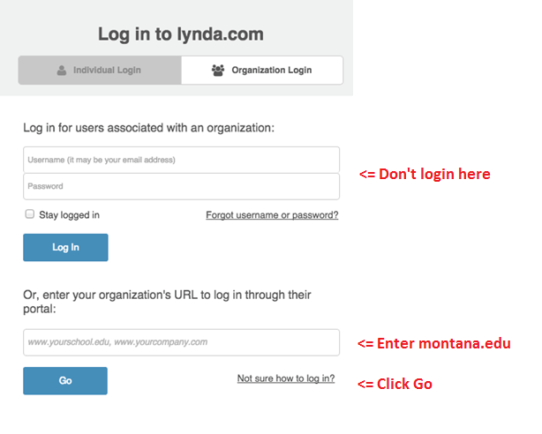

After logging in with your NetID, you will have the opportunity to merge your previous, self registered account as shown below. The reason you may want to do this is to maintain your account history.

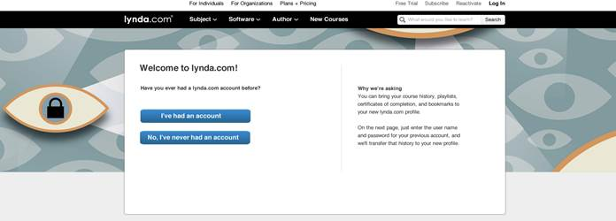

Make your choice and proceed. You will need your previous account credentials to merge the account.

Use the forgot password link if necessary.

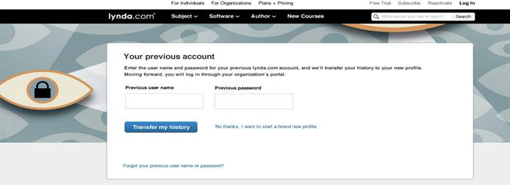

In keeping with good privacy practices and Library policies, we will not share your personal information with Lynda.com. We share your first name only. It is your choice whether to complete your profile on Lynda, in order to take advantage of email alerts or other services.

That’s it! Please let me know if you have any problems. You may continue to use Lynda.com in the meantime, but look for this change after 5 PM on September 1st.

Erik Guss

IT Systems Integration

MSU Bozeman Library